NON CONTACT TACHOMETER

ABSTRACT
The aim of the project is to design a contactless speed sensing device (tachometer) for a Brushless DC (BLDC) motor. Traditional tachometers require a physical contact to the shaft of the motor to measure the speed. In certain applications, where it is not feasible to measure the speed for safety and technical reasons, it is possible for a contactless tachometer to take the readings from a certain distance.
This proposed system uses the IR transmitting and receiving technique. This is achieved by receiving IR rays from a reflecting spot on the shaft of the motor. Such arrangements can measure the rate at which the IR rays are getting reflected back. The project uses a microcontroller of PIC family. A pair of sensors (Transmitter and receiver) is used to develop a pulse for each reflection that sends an interrupt to the microcontroller. The timer of the controller calculates the speed by each pulse received in a particular time interval and displays the same. The microcontroller is interfaced with an LCD to display the speed.
The concept of the contact-less tachometer can be enhanced and implemented in the bikes, cars for speed measurement, avoiding the use of traditional analog speedometer.
BLOCK DIAGRAM
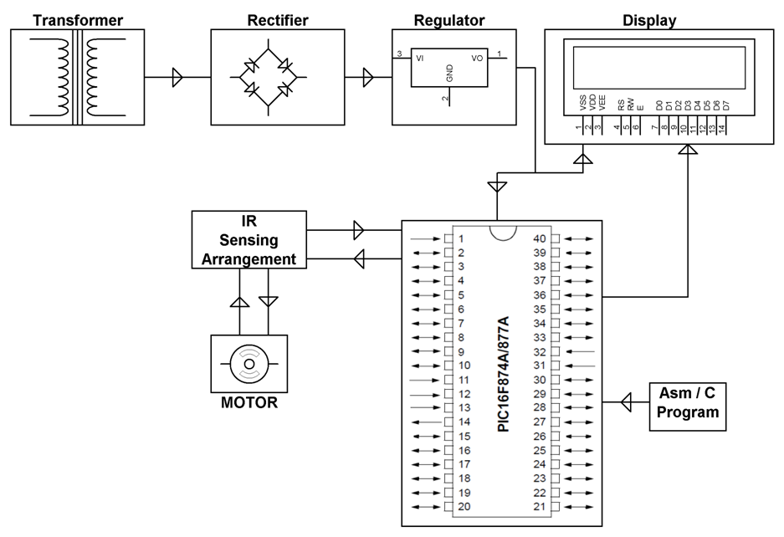

SOFTWARE REQUIREMENTS:

HITECH PICC Tool suite

Language: Embedded C or Assembly

HARDWARE REQUIREMENTS:

PIC series Microcontroller, LCD, IR and Photo Diodes, Transformer, Diodes, Resistors, Capacitors, Voltage Regulator, LED, BLDC Fan.

